Nandini Patel
Group 2
MSBA 710
Project Paper – Improving Student Test Scores

We were presented with a dataset of Students’ SC Ready Math > Vertical S scores with other student information variables. Our goal was to find the reasoning of low student test scores and provide recommendations and justifications to possible solutions. Based on the given dataset, the continuous variables were Student Days Absent and Student Discipline and our testing variable was SC Ready Math > Vertical S. The categorical variables were split into 3 factors of demographics, education status, and risk indicators. Student Gender, Student Race, Student Ethnicity-is Hispanic, and Student ZIP Code were the variables that covered the students’ demographics. Student Autism, Student Learning Disability, and Student Special Education were the variables that covered the students’ educational status. Finally, Student Free/Reduced lunch and Student PIP Status combined with our continuous variables were the variables that covered the students’ risk indicators. Additional variables that could have an influence to low student test scores are family life and instructional factors.
We were challenged to find the possible reasons of low test scores in these students and to find methods to increase the test scores. Based on the dataset, we believe that student test scores are impacted by inconsistent access to lunch, and frequent absenteeism is associated with lower student test performance. To better comprehend the dataset in layman’s terms, we had assigned Group 1 of Student Free/Reduced Lunch to paid lunch, Group 2 as free lunch, and Group 3 as reduced lunch. As such, we had noticed that students with free/reduced lunch access have scored a combined average of 570.06 on the SC Ready Math > Vertical S scores compared to students who don’t have access to free lunch, who scored an average of 555.33. However, these students also had a higher absenteeism range from 0-8 days compared to students that have no free lunch with a range of 1-3 days of absence. Hence, we generated a goal to increase the overall SC Ready Math test scores from 550 with a target average of 680 by the end of the 2026-2027 school year.
For our baseline analysis, we have conducted a graphical summary of SC Ready Math > Vertical S, our testing variable. Our null hypothesis assumes that our data follows a normal distribution. Our alternative hypothesis assumes that our data does not follow a normal distribution. Based on Figure 1, we can see that our variable has a mean of 559.3 with Quartile 1 at 482 and Quartile 3 at 614. Given these values, we had chosen 550 as our starting value and 680 as our target value for our goal statement. Since the p-value for the Anderson-Darling Normality Test is less than 0.005 which is less than 0.05, we can reject our null hypothesis and state that the mean is statistically significant and that our data does not follow normal distribution. As such, we can also observe several outliers in the boxplot that are higher than the maximum observation whisker.
Following our baseline analysis, we brainstormed possible root causes of low student SC Ready Math > Vertical S scores. Based on Figure 2, we have come up with several possible causes that are both related to the given dataset and from prior knowledge and experience of school lifestyles. For one possible root cause of low test scores, we believed that gender and sexuality could be a possible factor. The American Institute for Boys and Men, claims that, “Girls have long had an edge over boys when it comes to grades. In 2019, the average GPA for girls was 3.23 compared to 2.0 for boys” (Smith & Reeves, 2025). Additionally, if a student is a part of the LGBTQ+ community, typically most of there teen years is spent on students finding out who they really are and transitioning is a process that can possibly distract students from focusing on their studies. Another possible root cause is learning disabilities, special education, and race. Disabilities and language barriers from student race can hinder a given student from being able to learn course material effectively and as such there are special education classes and accommodations given to said students. We also believe that the type of lunch students receive can also affect test scores because if the student is fully nourished then they can focus on their studies and takes exams better. Additionally, ,when students are absent for multiple days from school they miss vital information about their coursework that would also appear in exams. These absents can occur on several accounts of sick days, bereavement, doctors appointments, or vacation time with family. Instructional factors such as class size, quality of instruction, and the location of the school can also affect the students’ learning periods. Some students understand the coursework better if they have more one-on-one time with the teachers or if the coursework is taught is different learning methods that adhere to visual, linguistic, or kinesthetic learners. The time it takes for students to travel between home and school can also cut back on study periods for students when they revise the curriculum. Finally, family life can affect the students’ study and homework time if the students are a family caretaker, have jobs, are athletes, have children to look after, or do not have financial stability to support them during there educational process.
To test which variables affect SC Ready Math > Vertical S Scores, we have performed ANOVA General Linear Model and Multiple Regressions on Minitab with different inputs. First, we perform an ANOVA GLM on SC Ready Math > Vertical S by the Student Free/Reduced Lunch and the Student Days Absent variables. Based on Figure 3A, the Analysis of Variance table shows that both variables have a p-value of 0.000 which indicates that the means and variances of the variable when compared to SC Ready Math > Vertical S are not equal to each other and are statistically significant. Figure 3B, focuses on the individual values within the Student Free/Reduced Lunch variable and Student Days Absent variable. Based on the p-values, we can see significant values when Student Free/Reduced Lunch is 2 and when Student Days Absent is either 1 or 2. Additionally, Figure 3B contains the VIF (Variance Inflation Factor) that measures multicollinearity between variables. Overall, we can state that since the VIF values are between 1.26 and 2.95, there is some correlation between independent variables. Finally, the Residual Plots indicates that the data follows a normal distribution since the normal probability plot follows the linear line, the versus fits residuals are scattered randomly around zero, the histogram is bell-shaped with a slight skew to the left, and the versus order residuals are randomly scattered with no obvious patterns.
We had conducted two additional ANOVA tests to determine the model with the best p-values. For our first ANOVA (Figure 4), we had conducted an ANOVA of all of the variables within the dataset which indicated we had four p-values that were significant. After performing Best Subsets, we had removed Student Gender and Student ZIP Code from the first ANOVA and as such we had end up with six statistically significant p-values (Figure 5).
Finally, we had conducted a Multiple Regression on SC Ready Math > Vertical S with the Student Free/ Reduced Lunch variable and the Student Days Absent variable. Based on Figure 6A Analysis of Variance table, we can see that both variables have a p-value of 0.000 which indicates that there is statistically significant data that proves that at least one variable coefficient does not equal 0. Additionally, based on Figure 6B, we can observe that the normality probability plot follows the linear line, the versus fits residuals are scattered randomly around zero, the histogram is bell-shaped with a slight skew to the left, and the versus order residuals are randomly scattered with no obvious pattern. Therefore, we can claim that the data follows a normal distribution.
Next, we have brainstormed possible solutions to increase student test scores as shown in Figure 7. One way we can increase student test scores is by reducing absenteeism range to 1-2 days. We can achieve this by increasing student activities and events on school grounds such as hosting more after school activities, pep rallies, and family events. These activities and events will build a stronger community and better communication between the school, students, and families. Additionally, to address the students who may have a more difficult time reaching school on time, we can create additional bus routes or have other students or faculty car pool students near there area to ensure every student is able to each school on time. We can also ensure that school creates and regularly follows up with student PIP status. This can be achieved with MAP Testing at least 3 times a year, SMART goals for the students to set and achieve by the end of each curriculum chapter, mentoring and scheduled meetings for students who need additional time to understand the material. Furthermore, we can increase test scores by ensuring that special education and students with disabilities are given more accommodations. For instance, we can increase the number of special education teachers, have accommodations for testing, and have certified counseling services during the beginning of each school for all the students to check for any disabilities that even the students didn’t know they had. Finally, we can ensure that the students that are being disciplined for misconduct still have an opportunity to make up missed assignments and exams, either in-person or online. We can also put these students in counseling/therapy to determine if there are any underlying issues that affect their behavior and in-turn risk their educational learning. By engaging with students more these problems can be fixed and the school can promote better learning environments for the students to gain better test grades.
Overall, based on the multiple ANOVA GLM models, we can claim that Student Special Education, Student Ethnicity-is Hispanic, Student Race, Student PIP Status, Student Days Absent, Student Discipline, and Student Free/Reduced Lunch are all statistically significant. Based on the multiple regression model, we can claim that Student Days Absent and Student Free/Reduced lunch are highly significant to SC Ready Math > Vertical S scores. We recommend that the stakeholders focus on these variables to have the greatest impact to improve on student testing scores. For instance, increasing recreational activities to promote motivation, accommodations for testing and student transportation, improved learning practices, and providing more free/reduced lunches to the students can all improve on student test scores and promote a better learning experience for the students.
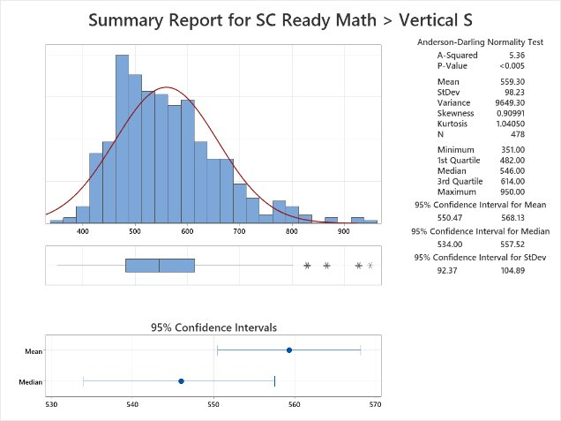
Figure 1. Graphical Summary for SC Ready Math > Vertical S variable

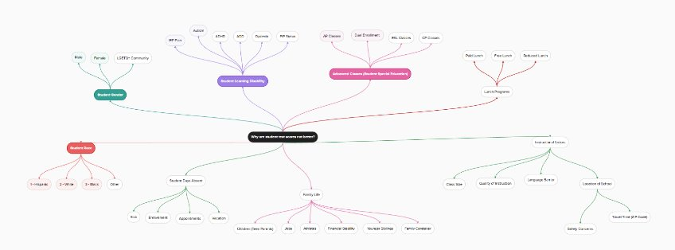
Figure 2. Root Cause Brainstorming Mind Map

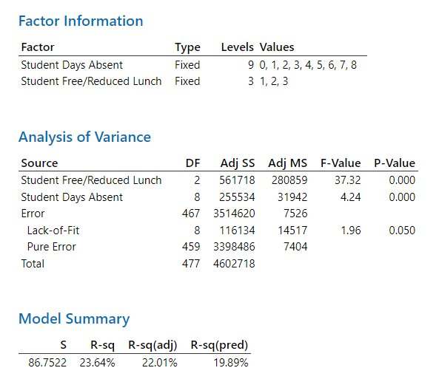
Figure 3A. ANOVA GLM – ANOVA Table

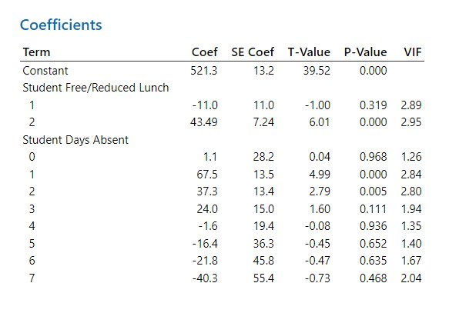
Figure 3B. ANOVA GLM – Coefficients Table
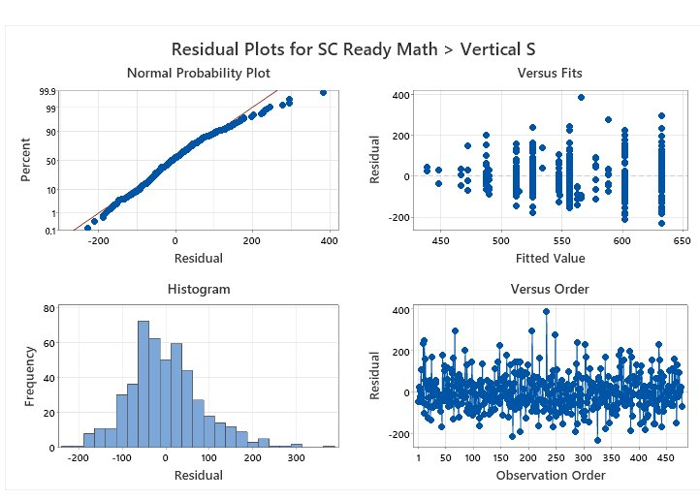
Figure 3C. ANOVA GLM – Residuals Plots

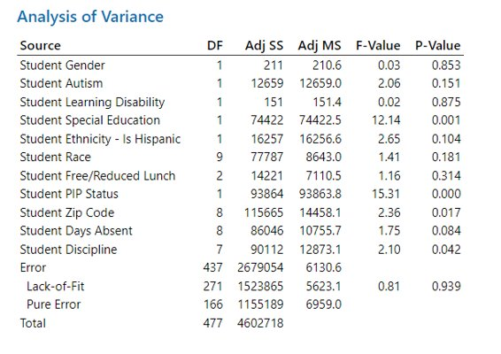
Figure 4. ANOVA – All Variables
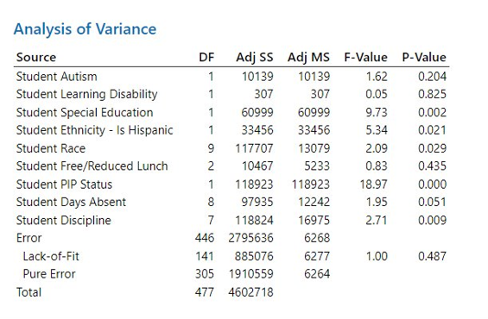
Figure 5. ANOVA – Student Gender and Student ZIP Code removed
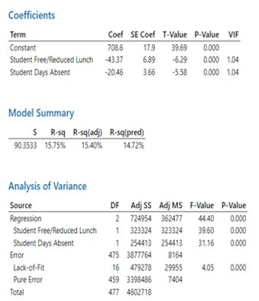
Figure 6A. Multiple Regression – ANOVA
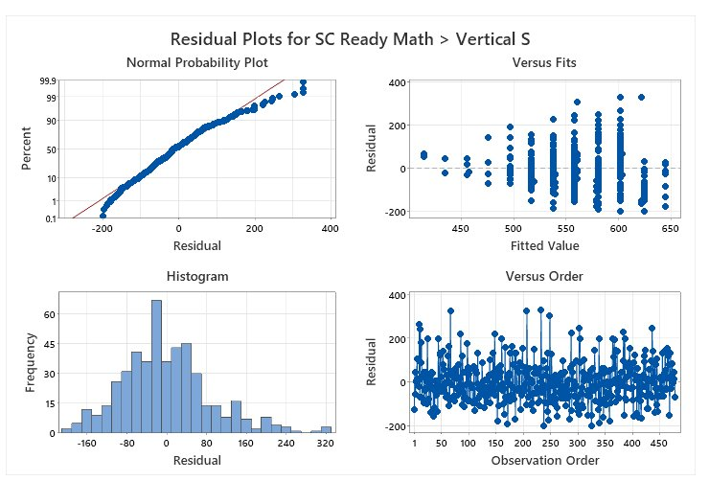
Figure 6B. Multiple Regression – Residuals Plot
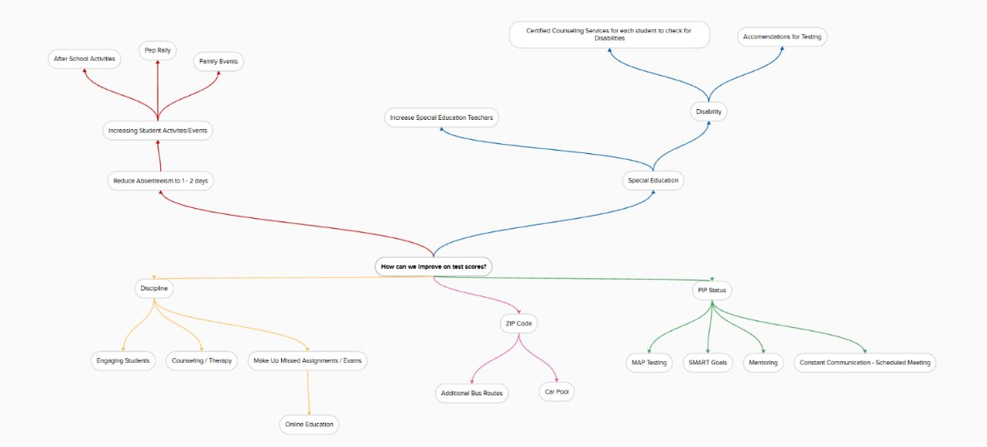
Figure 7. Solutions Brainstorming Mind Map

References
Smith, B., & Reeves, R. V. (2025). Boys, girls, and grades: Examining GPA and SAT trends. Retrieved from https://aibm.org/research/boys-girls-and-grades-examining-gpa-and-sat-trends/

